**Project #3**

**Embedded Software Design**

1. **Fully Dynamic Design.**
   * + ECU1 Components State Machine
       - Speed
       - Switch
       - Door



* + - * Communication



* + - ECU1 Sequence Diagram



* + - ECU1 CPU Load
      * CPU will be calculated offline using simso
      * EDF schedule
      * Tasks Execution time (Assumed for all tasks):

➔ Assume all tasks take 1ms for execution.

CPU Load = ((4*1) + (4*1) + (1*1) + (2*1)) / (20)

= 0.55

= 55%

* + - * ECU1 SIMSO Gantt Chart & CPU Load

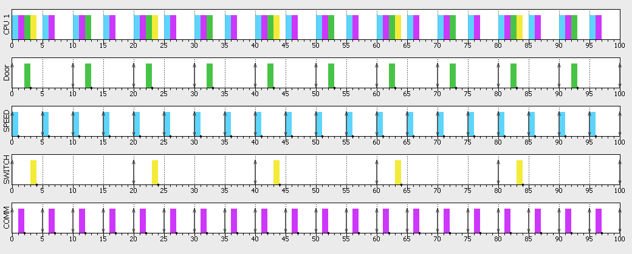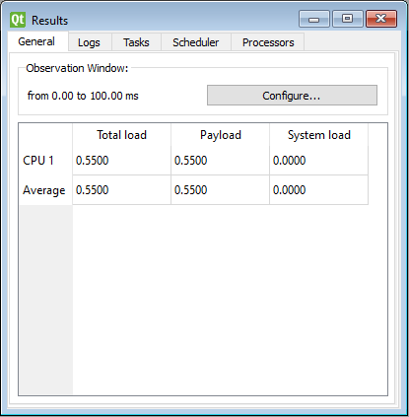

* + - ECU2 Components State Machine
      * Communication
      * Processing



* + - ECU2 Sequence Diagram



* + - * CPU will be calculated offline using simso
      * EDF schedule
      * Tasks Execution time (Assumed for all tasks):

➔ Assume all tasks take 1ms for execution.

CPU Load = ((1*1) + (1*1)) / (5)

= 0.4

= 40%

* + - * ECU1 SIMSO Gantt Chart & CPU Load

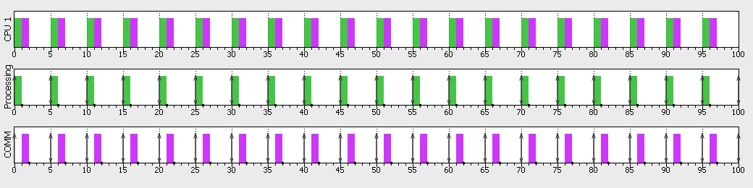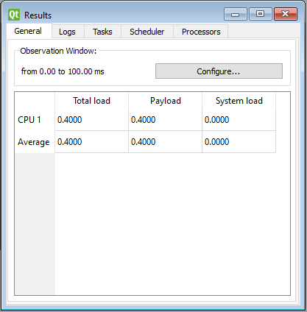

* + - CAN BUS Load Calculation:

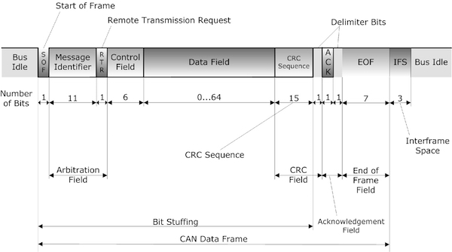

the entire frame has a length between 47 and 111 bits, depending on the length of the data field, which can be between 0 and 8 bytes (0 and 64 bits).

At a baud rate of 1 MBit/sec

Therefore, total number of bits sends via the bus in 1 second =

Message Rate * Message Size = 200 * 111 = 22,200 bits/s

Bit sending time = (1/ (1024*1024)) sec

 

Frame sending time = 22200 * (1/ (1024*1024)) = 0.021171sec

 Therefore, Bus Load in one second = 2.12 %